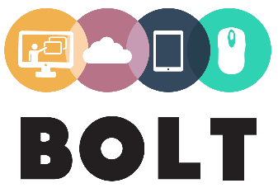
Learning Innovation Plan Template

Name: Click here to enter text.  Email: Click here to enter text. | Role: Click here to enter text.  Institution: Click here to enter text.
- LEARNING AND TEACHING CONTEXT
- Include a description of your learners and your class, e.g. the level of your class, number of students, and their characteristics, such as their age, learning preferences, motivation for learning, experience of educational technologies and information literacy skills
- Describe your learning and teaching scenario, e.g. the physical environment and the course learning aims
- Include input to be covered as part of your learning innovation, e.g. mode of delivery of the learning activity
What is your learning and teaching context?
- LEARNING INNOVATION RATIONALE
- Describe the rationale behind your learning innovation
- Include a reason for choosing this particular learning and teaching scenario for your innovation and the reasons behind choosing the approaches and technologies that you did
- Give specific examples of how your scenario will benefit from a flipped classroom approach
What is the rationale behind your learning innovation?
- INTENDED LEARNING OUTCOMES
- List the ILOs of your learning innovation
- Give detailed descriptions of your ILOs, e.g. what kind of knowledge and academic, technical or social skills are targeted as ILOs? For example, does your innovation aim to increase students’ motivation and their ability to progress in your subject? What will students learn through your innovation?
- Explain how the ILOs of your learning innovation align with those of your course or subject
What are the intended learning outcomes of your learning innovation?
- LEARNING INNOVATION
- Describe your learning innovation
- State clearly what will be face-to-face, what will be online and how these two learning environments are connected
- Describe the step-by-step stages of your learning activity
- Explain what kind of resources, tools and learning content you will use
- Describe the interactions that will occur at each stage. For example, will students interact with you or with each other? Will they work individually or collaboratively?
- Describe the strategies you will use to ensure student engagement and participation
- Describe how learning will be assessed. Will assessment will be formal or informal?
- Describe the time frame for your innovation and outline any follow-up or extension activities that students will do
Describe your learning innovation
- LEARNING SUPPORT
- Describe any learning support you will provide, e.g. detailed instructions, technical support, other teacher-led support or peer support
What learning support will you provide?

